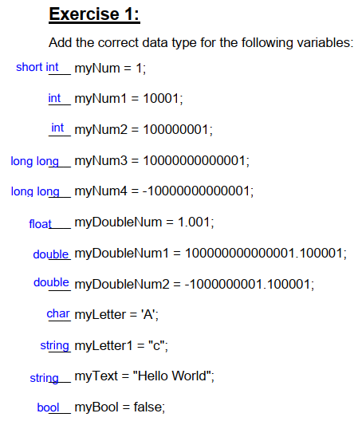

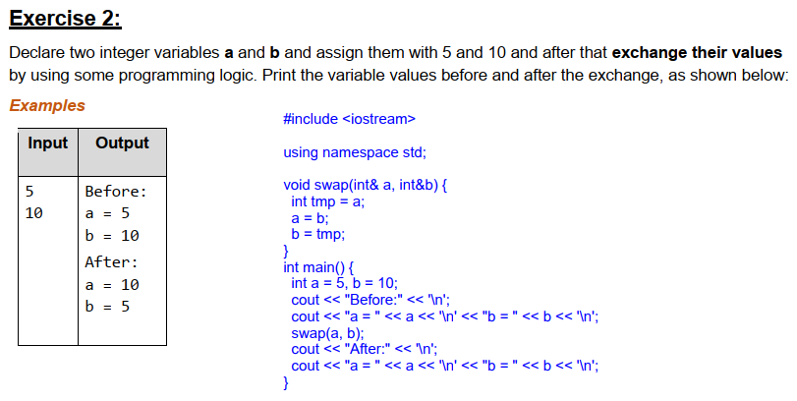

#include <iostream>

using namespace std;

void swap(int& a, int&b) {

  int tmp = a;

  a = b;

  b = tmp;

}

int main() {

  int a = 5, b = 10;

  cout << "Before:" << '\n';

  cout << "a = " << a << '\n' << "b = " << b << '\n';

  swap(a, b);

  cout << "After:" << '\n';

  cout << "a = " << a << '\n' << "b = " << b << '\n';

}

#include <iostream>

using namespace std;

int main() {

  int a, b;

  cin >> a >> b;

  cout << "Sum(a, b) = " << a + b << '\n';

  cout << "Diff(a, b) = " << a - b << '\n';

}

#include <iostream>

using namespace std;

struct Employees {

    string firstName;

    string lastName;

    int age;

    string gender;

    string personalID;

    string uniqEmpNum;

};

int main() {

  Employees emp;

  cin >> emp.firstName >> emp.lastName >> emp.age

  >> emp.gender >> emp.personalID >> emp.uniqEmpNum;

  cout << emp.firstName << '\n';

  cout << emp.lastName << '\n';

  cout << emp.age << '\n';

  cout << emp.gender << '\n';

  cout << emp.personalID << '\n';

  cout << emp.uniqEmpNum << '\n';

}